STOP SMOKING FOR SAFER SURGERY
PATIENT "QUIT CARD"

Patients get a great deal of information given to them during a pre-admission visit. They are easily overwhelmed and can forget things. It is useful to be able to give them some written information they can review later.

The “Quit Card” is a 7 x 7 cm card, small enough to fit in a wallet or bill fold but bigger than a business card, so it stands out.
It can be distributed by anesthesiologists and put in preadmission areas, and perhaps also used in surgical clinics or GP offices.
It gives patients the basic message and provides a link to further resources for information about the risks of smoking before surgery and how to get help to stop smoking.

FRONT | BACK
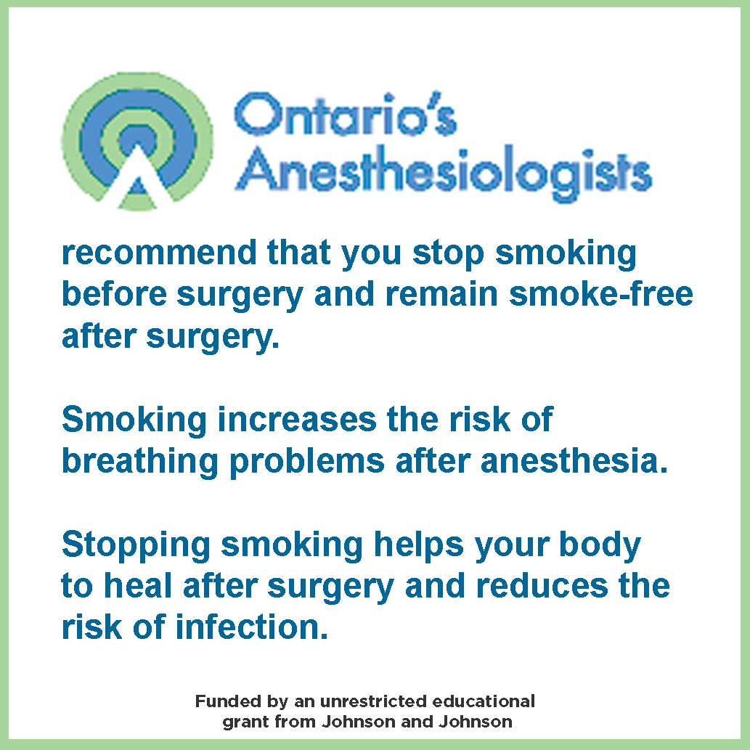 | 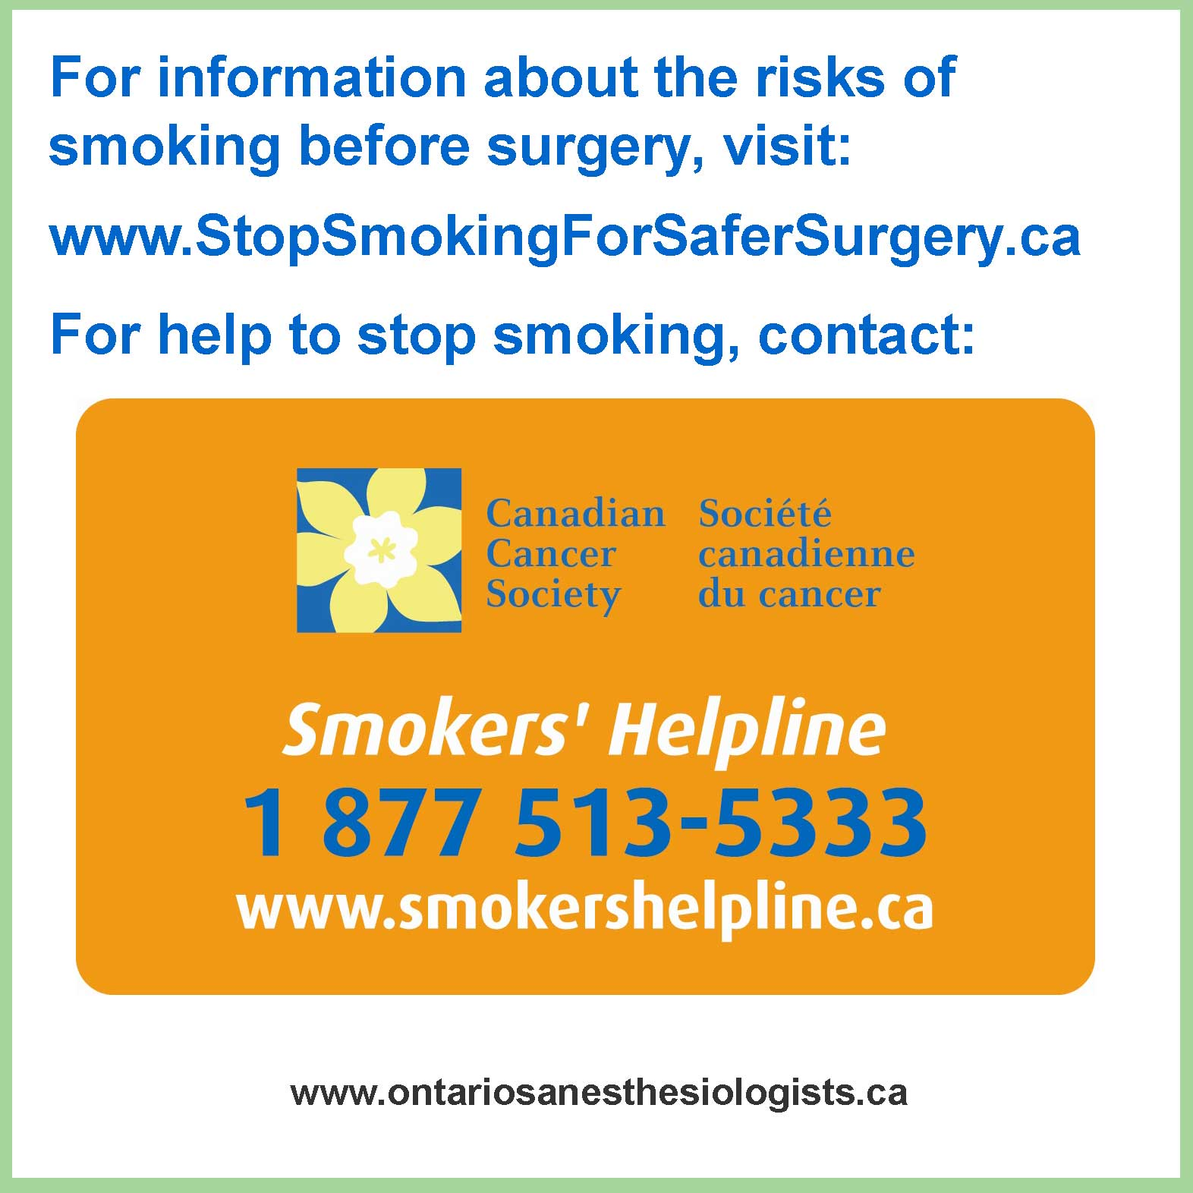

This version was distributed by Ontario’s Anesthesiologists in 2009, but it can be adapted to meet the needs of any clinic, hospital or organization.

